Open Source Software –
Evaluated Course Project

Chosen Software: VLC

Submitted by:

Tatikonda Aditya

24BCE11182

28th March, 2026

Part A — Origin and Philosophy (Units 1 & 2)

A1. Origin Story of VLC: From a Dorm Room to Four Billion Downloads

The story of VLC Media Player is one of the most interesting tales in software history. It shows how a small group of students, frustrated by a specific technical issue, created a tool that later shaped an entire category of digital utilities for billions of people around the globe.

The Spark of Innovation (1996)
The journey began in 1996 at École Centrale Paris, a top French engineering school often compared to the prestigious Indian Institutes of Technology (IITs). At that time, the campus network was a place for experimentation, but it had a major challenge. The students wanted a way to stream television and high-quality video across the university’s local area network (LAN). They named this initiative VideoLAN. However, the mid-90s digital scene was chaotic. To play a video file, users had to rely on proprietary software. Programs like Windows Media Player and RealPlayer were very restricted, platform-specific, and often failed when trying to handle formats outside their limited range. There was no free, open-source tool that could both stream video over a network and decode various formats.

The Great Codec Breakthrough
By 2001, the project hit a key moment when VLC (VideoLAN Client) was released to the public under an open-source license. What happened next changed VLC from a student project into a global icon. The main problem for computer users in the early 2000s was the annoying "Codec Not Found" error. To play different video types, users often had to search for and install unreliable "codec packs" that could crash their systems or contain malware. The students at École Centrale Paris solved this with a clever engineering approach: they included every necessary codec right in the software. By making VLC self-contained, they ensured it would work effortlessly. Whether it was an obscure MPEG version or a damaged AVI file, VLC was built to bypass system limitations and play the data directly. This idea of broad compatibility was revolutionary.

A Legacy of Independence
What started as a wish to watch TV on a computer monitor grew into a global sensation. Today, VLC has more than 4 billion downloads. It acts as the "Swiss Army Knife" of media, running smoothly on Windows, macOS, Linux, Android, and iOS. Perhaps the most impressive part is that the organization behind it has stuck to its roots. Despite its huge success, the VideoLAN organisation remains a non-profit. There was never a large IPO, no venture capital funding to manage, and no corporate takeover that would compromise user experience with ads or tracking. It is still a community-driven project, supported by volunteers who believe in the original mission of open access.

Key Takeaways
• Origin: Started in 1996 by students at École Centrale Paris.
• Philosophy: Built out of frustration to address the "proprietary software" problem.
• The "VLC Secret": Internalised codecs that allow it to play almost any file format without external help.
• Scale: Over 4 billion downloads and available on every major operating system.
• Governance: Operated by a non-profit, showing that community-led software can outperform billion-dollar companies.

The story of VLC serves as a strong reminder for any engineering student. The most world-changing tools often begin as simple solutions to personal problems.

A2. The License: Freedom by Design
If the VLC origin story focuses on student innovation, its license emphasises long-term survival and ethics. VLC isn't merely free to download; it operates under a legal framework that ensures it serves the people, not a locked-down corporate product.

The Power of the "Four Freedoms"
VLC is classified as Free and Open Source Software (FOSS). This means more than being free of charge; it refers to the Four Essential Freedoms defined by the Free Software Foundation, which VLC provides to every user:
1. Freedom 0: The freedom to run the program for any purpose, whether commercial, personal, or educational.
2. Freedom 1: The freedom to study how the program works and change it. Access to the source code is essential.
3. Freedom 2: The freedom to share copies so you can help your neighbour.
4. Freedom 3: The freedom to distribute copies of your modified versions to others.

Dual Licensing: The Strategic Middle Ground
VLC employs a smart "dual-licensing" strategy to maximise its reach. It’s not just a single license; it’s a tiered system:
• The Core (LGPL v2.1): The engine of VLC, called libVLC, uses the Lesser General Public License. This "weak copyleft" license allows companies to use VLC’s playback engine in their own proprietary (paid or closed) apps without forcing them to share their private code. That's why you see VLC technology in numerous commercial video apps and professional tools.
• The Player (GPL v2): The actual VLC app you see on your screen is licensed under the General Public License. This is "strong copyleft." If a company modifies the VLC player’s interface and distributes it, they must share their modified source code with everyone. They cannot turn the player into a private, secret product.

GPL vs. MIT: The VLC Philosophy
To understand VLC's choice, compare it to the MIT License.
• MIT is like a "gift": You can take this code, do whatever you want, owe nothing to us, and never share your changes.
• GPL is like a "social contract": You can use it for free, but if you improve it and share it, you must give those improvements back to the community.

LGPL acts as the middle ground. It's permissive enough for companies to build upon it (like MIT), but strict enough to keep the core library open (like GPL).

"Free Beer" vs. "Free Freedom"
There's a common saying in software: "Free as in speech, not free as in beer." While VLC is both free of charge and promotes freedom, its commitment to "freedom of speech" sets it apart.

A prime example is DRM (Digital Rights Management). Many popular video formats are encrypted to prevent copying. To play these "officially," a software company must pay fees and agree to lock their software so users can't record or modify the stream.

VLC refuses to do this. Supporting certain DRM formats would force VLC to abandon its "Open Source" status, as the decryption keys would need to remain hidden and secret. The VideoLAN team believes user freedom is more important than convenience. They would rather not support a specific restricted format than compromise their code's open nature. It's a statement of values: VLC belongs to the users, not the content multi-billionaires.

A3. The License: Freedom by Design
The success of VLC raises an important ethical question that all software engineers face: Should all software be open source? Although the idea of "free as in speech" sounds appealing, maintaining a global standard like VLC reveals a complicated struggle between community goodwill and corporate greed.

The "Chain of Giants": Standing on Shoulders
The ethical strength of VLC lies not just in what it created, but in what it inherited. VLC didn’t develop video decoding from the ground up; it relies on FFmpeg, another major open-source project that handles the heavy lifting of audio and video processing.

This forms a rewarding chain of progress: FFmpeg provides the engine, VLC offers the vehicle, and billions of users benefit from the journey. In this ecosystem, progress isn’t slowed by patents or paywalls. Ethically, this approach is better because it avoids "reinventing the wheel." If every company kept its codecs secret, digital media would be fragmented, costly, and inefficient. Open source makes breakthroughs beneficial for everyone.

The Parasite Problem: Profiting Off Community Labour
However, this openness has a downside. Because VLC’s code is public, it has attracted "re-packagers." Many companies have taken the VLC source code, added a new logo, bundled it with adware or malware, and sold it to unsuspecting users.

This creates a significant ethical issue:
- The Developers' Burden: Volunteers at VideoLAN dedicate thousands of hours debugging code for free.
- The Corporate Play: A company with a marketing budget takes that work, adds no value, and profits from it.

VideoLAN has had to take legal action to protect its trademark and ensure users aren’t being deceived. This situation highlights the "Open Source Paradox": to keep a project truly free and secure, you sometimes need to act like a traditional business and hire lawyers to defend your "free" territory.

The LGPL Compromise: A Deliberate Tension
VLC’s decision to use the LGPL license for its core libraries is an interesting ethical compromise. By allowing companies to use libVLC in proprietary software without sharing their private code, the VideoLAN team chose to prioritise adoption over strict openness.

They recognised that if they were too strict, large companies would simply create their own closed-source versions. By being "permissive," they ensured that VLC technology became the industry standard, even if it allows some companies to profit without contributing back. It's a practical trade-off: they prefer the world to run on open-source "engines" (even if the "car body" is private) rather than see the entire industry confined behind proprietary barriers.

My Take: The Hybrid Future
In my opinion, while the world would be more innovative if all software were open source, it isn’t always financially viable. Essential infrastructure (like VLC, browsers, and operating systems) should remain open source because they serve as the "public roads" of the internet. No one should control the "road" you use to access information.

However, for specialised, high-end tools, a proprietary model can support the large R&D budgets that open-source projects often struggle to generate. The lessons from VLC remind us that the best software isn't necessarily the one that earns the most money, but the one that empowers the most people while staying true to its origins.

Part B — VLC on Linux (Unit 2)

Installation Method
One of VLC's biggest strengths on Linux is how easy it is to get installed. It's available in the default repositories of almost every major distribution, so there's no hunting for third-party sources — just one command, and you're done:
Ubuntu/Debian: sudo apt install vlc
Fedora: sudo dnf install vlc
Arch: sudo pacman -S vlc
For those who prefer universal packaging formats, Snap and Flatpak versions are also available:
sudo snap install vlc
Compiling from source is also possible by downloading from videolan.org, though that's generally only necessary for developers or people who need a very specific build configuration.
The more important takeaway here is what being in official repositories actually means for security: when you run a system update (sudo apt upgrade), VLC gets patched along with everything else automatically. There's no separate update checker, no popups asking you to download the new version manually. Security fixes from the community get reviewed publicly, pushed to distro repos, and land on your machine through the package manager. That's the open source security model working exactly as it's supposed to.

Key Directories
After installing VLC on a Linux system, its files are distributed across the filesystem in a well-organised way. Here's where everything lives:

Path | What's There
/usr/bin/vlc | The main executable — this is what actually runs when you type vlc in the terminal.
/usr/lib/vlc/ | All the plugin files — every codec module VLC supports lives here.
/etc/vlc/ | System-wide configuration (may not exist on all distros).
~/.config/vlc/ | Per-user config — your personal preferences, playlist history, customisations.
/usr/share/vlc/ | Skins, icons, and Lua scripts for extensions.
/usr/share/doc/vlc/ | Documentation and license files.

The pattern here isn't random — VLC follows the Linux Filesystem Hierarchy Standard (FHS), the convention that dictates where different types of files should live on a Linux system. Binaries go in /usr/bin, system-wide configs in /etc, user-specific configs in ~/.config, and documentation in /usr/share/doc. This is exactly how well-behaved Linux software is supposed to be organized, making it predictable for both users and system administrators.

User and Group
VLC runs as the currently logged-in user — it doesn't create or require a special system account. This is worth paying attention to because it has real security implications.
When you open VLC, it runs with exactly your permissions and nothing more. It can access your files, your home directory, your media — whatever you can access. But it can't touch things outside your user's scope. It doesn't run as root, and it doesn't ask for elevated privileges just to play a video.
Compare this to something like Apache (a web server), which runs as a dedicated low-privilege user called www-data. Apache runs constantly in the background and is directly exposed to internet traffic, so giving it a restricted system identity limits the damage if it gets compromised. VLC, on the other hand, only runs when you open it, so it simply inherits your session.
The practical upside: if VLC were somehow exploited while playing a malicious video file, the damage is contained to your user account. A bad actor couldn't use that vulnerability to take over the entire system.

Service Management
VLC is not a background service — it's an application. You don't start it with systemctl, it's not listening on a port 24/7, and it doesn't run at boot. You open it when you need it, and that's it.
That said, VLC does have a command-line interface and can run in a headless mode (without any GUI). This makes it surprisingly flexible as a streaming server when needed:
vlc --intf dummy --loop video.mp4
Running it this way, you could wrap VLC in a systemd service to have it stream video continuously in the background — effectively turning it into a lightweight streaming server. Most people never need this, but the capability is there.
This is actually a broader point about Linux software design: what most people think of as 'just an app' can often be run as a background service. VLC is a clean example of that flexibility.

Update Model
On most Linux systems, VLC updates are handled entirely through the package manager. On Ubuntu, for example:
sudo apt update && sudo apt upgrade
VLC gets updated right alongside the rest of your system packages. No separate update checker, no installer to run. VideoLAN also releases updates directly on their website for users who have installed manually.
The update pipeline works like this: a security patch gets developed by the community, reviewed publicly on VideoLAN's GitLab, pushed to distribution repositories, and then delivered to your machine through your package manager. Compare that to proprietary software, where you're entirely dependent on the company discovering the bug, deciding it's worth fixing, building a patch, and actually releasing it — on their timeline, with no public accountability.

Part C — The FOSS Ecosystem Around VLC (UNITS 3 & 4)

Dependencies — What VLC Is Built On
VLC isn't a standalone piece of software that one team wrote from scratch. It's more like a carefully assembled stack of open source components, most of which are large, independent projects in their own right. Pull any of them out and VLC loses significant functionality.
Here are the major ones:
- FFmpeg — arguably the most important dependency. FFmpeg is an open source library that handles encoding and decoding of virtually every audio and video format that exists. VLC leans on it heavily for format support. Interestingly, FFmpeg itself is used by YouTube, Netflix, Facebook, and most of the video processing infrastructure on the internet.
- libVLC — VLC's own core media engine, which is itself released as an open source library that other developers can build on top of.
- Qt — the framework used to build VLC's graphical interface. Qt is also the framework behind the entire KDE desktop environment.
- zlib — handles data compression.
- libpng / libjpeg — image handling libraries.
- Lua — a lightweight scripting language used for VLC extensions and playlist parsing.

The bigger point here is that VLC represents the 'standing on the shoulders of giants' principle in practice. Open source thrives because projects share infrastructure. Remove FFmpeg from VLC, and it loses the ability to play half the formats it supports. This kind of dependency graph — where massive projects depend on and feed back into each other — is what makes the FOSS ecosystem work.

What VLC Enabled and Inspired
Beyond what VLC depends on, it's also worth looking at what it gave back to the ecosystem — and what it inspired:
- libVLC — VLC's core is available as a standalone library. Dozens of third-party media players and applications are built directly on top of it.
- Kodi (formerly XBMC) — took inspiration from VLC's 'plays everything' philosophy and expanded it into a full home theatre operating system.
- HandBrake — a popular video converter that uses FFmpeg (just like VLC) and shares the same philosophy of making media tools free and accessible.
- MPV — a minimalist media player that forked from MPlayer, carrying forward the same open codec approach.

VLC proved that a community-built, free media player could actually be better than any commercial alternative. That proof-of-concept inspired a whole generation of open media tools.

Where VLC Fits — LAMP Stack Connection
VLC isn't directly part of the LAMP stack (Linux, Apache, MySQL, PHP) — it's a media player, not a web server component. But there are a few meaningful connections worth drawing:
First, the 'L' in LAMP: Linux. VLC is a flagship example of software that only thrives because Linux exists as a free, open platform. It's one of the clearest demonstrations of what free software ecosystems can produce.
More practically, VLC can act as a streaming server using RTSP or HTTP. So a real-world setup could look like: a Linux server running Apache to serve a webpage, with VLC streaming video content to that page. VLC fits into the media layer of a web stack.
And then there's FFmpeg — VLC's core dependency — which is actively used by YouTube, Netflix, and Facebook for their video processing pipelines. VLC's dependency tree overlaps with Big Tech infrastructure in ways most people don't realise.

Community and Governance
VLC is developed and maintained by VideoLAN, a French nonprofit organisation. Development happens on their own self-hosted GitLab instance at code.videolan.org (not GitHub), with coordination through mailing lists and IRC channels on Libera.Chat (#videolan).
There's no corporate owner. Contributions come from volunteers worldwide, and VideoLAN holds an annual VideoLAN Dev Days conference for the community.
One thing worth highlighting: VideoLAN has actually pursued legal action against companies that violated VLC's GPL license by distributing it without releasing their modifications as open source. Most open source projects don't have the resources or willingness to do this. The fact that VideoLAN enforces its license is significant — it means the GPL isn't just symbolic for this project.

Part D — Open Source vs. Proprietary

The Proprietary Alternatives
VLC's main commercial and proprietary competitors have been Windows Media Player (Microsoft), QuickTime (Apple), and freemium players like KMPlayer and PotPlayer, both developed in South Korea.
Here's how they stack up:

Dimension | VLC (Open Source) | Windows Media Player / QuickTime
Cost | 100% free, forever. No trials, no premium tier, no nonsense. | Free but proprietary. WMP is discontinued. QuickTime on Windows was abandoned in 2016.
Security | Source code is fully public — anyone in the world can audit it for vulnerabilities. | Closed source. You just have to trust Microsoft or Apple to catch every bug. That's a big trust.
Support | Community forums, VideoLAN wiki, Stack Overflow — a huge ecosystem of help. | Official support from Microsoft/Apple, but very limited for discontinued products.
Freedom to Modify | Full freedom under GPL — fork it, modify it, ship your own version legally. | Zero. You get a binary, and that's it. No peeking, no touching.
Community vs Corporate | Nonprofit VideoLAN + volunteer contributors worldwide. | Single corporate owner controls everything — development, updates, discontinuation decisions.
Verdict | Best choice across every platform and format. | WMP is essentially dead. QuickTime on Windows was flagged as a security risk by US-CERT in 2016.

Conclusion
Would we recommend VLC for real-world use? Without hesitation. VLC plays every format without requiring separate codec packs, runs on every major operating system, has zero ads, zero telemetry, and no 'premium' version trying to upsell you. For a media player, the choice is obvious. Even in enterprise settings — training videos, presentations, internal media review — VLC is typically the default recommendation precisely because there's nothing to configure, license, or pay for. The fact that it's maintained by a nonprofit with no profit motive means it won't suddenly get paywalled, rebranded, or quietly discontinued the way Windows Media Player was.
As for contributing, VLC's core is written in C/C++, which raises the bar for direct code contributions as a beginner. But VideoLAN also needs help with documentation, translations, Lua scripts for extensions, and detailed bug reports. Contributing isn't always about committing code. Having done this audit and understanding the philosophy behind VLC — that media freedom matters, and that software doesn't have to cost money to be excellent — makes even small contributions feel meaningful. Filing a well-documented bug report is a real contribution to a project used by hundreds of millions of people worldwide.

Part E — Shell Script Documentation (Units 1, 2 & 5)
Five shell scripts were written and tested on Linux. Each is submitted as a separate .sh file. Documentation for each script is presented below, including its purpose, shell concepts demonstrated, and a description of expected output.

Script 1 — System Identity Report
File: script1_system_identity.sh
Displays a formatted welcome screen with system identity information. It collects the Linux distribution name, kernel version, logged-in user, home directory, system uptime, current date/time, and the open-source licenses covering the OS and VLC.
Shell Concepts: Variables, command substitution $(), echo formatting, cat /etc/os-release, grep, cut, uname, whoami, uptime, date
Script Code
#!/bin/bash
# ============================================================
# Script 1: System Identity Report
# Author: Tatikonda Aditya | Reg No: 24BCE11182
# Course: Open Source Software | OSS NGMC Capstone Project
# Description: Displays system info like a welcome screen
# showing OS, kernel, user, uptime and license.
# ============================================================

# --- Student & Software Variables ---
# Variables in bash: just NAME="value", no spaces around =
STUDENT_NAME="Tatikonda Aditya"
REG_NO="24BCE11182"
SOFTWARE_CHOICE="VLC Media Player"

# --- Collect system info using command substitution ---
# $() means: run this command and store its output as a value
KERNEL=$(uname -r)
DISTRO=$(cat /etc/os-release | grep "^PRETTY_NAME" | cut -d= -f2 | tr -d '"')
USER_NAME=$(whoami)
HOME_DIR=$HOME
UPTIME=$(uptime -p)
CURRENT_DATE=$(date '+%A, %d %B %Y')
CURRENT_TIME=$(date '+%H:%M:%S %Z')

# --- License info ---
OS_LICENSE="GNU General Public License v2 (GPL v2) - Linux Kernel"
VLC_LICENSE="GNU Lesser General Public License v2.1 (LGPL v2.1)"

# ============================================================
# Display the welcome screen using echo
# ============================================================
echo "================================================================"
echo " OPEN SOURCE AUDIT - System Identity Report "
echo "================================================================"
echo ""
echo " Student : $STUDENT_NAME"
echo " Reg No : $REG_NO"
echo " Software : $SOFTWARE_CHOICE"
echo ""
echo "----------------------------------------------------------------"
echo " SYSTEM INFORMATION"
echo "----------------------------------------------------------------"
echo " Distribution : $DISTRO"
echo " Kernel : $KERNEL"
echo " Logged User : $USER_NAME"
echo " Home Dir : $HOME_DIR"
echo " Uptime : $UPTIME"
echo " Date : $CURRENT_DATE"
echo " Time : $CURRENT_TIME"
echo ""
echo "----------------------------------------------------------------"
echo " LICENSE INFORMATION"
echo "----------------------------------------------------------------"
echo " OS License : $OS_LICENSE"
echo " VLC License : $VLC_LICENSE"
echo ""
echo " LGPL v2.1 allows companies to use VLC's core library (libVLC)"
echo " in proprietary software, while the full VLC player stays GPL."
echo " This dual approach maximises both freedom and adoption."
echo "================================================================"

Screenshot Placeholder
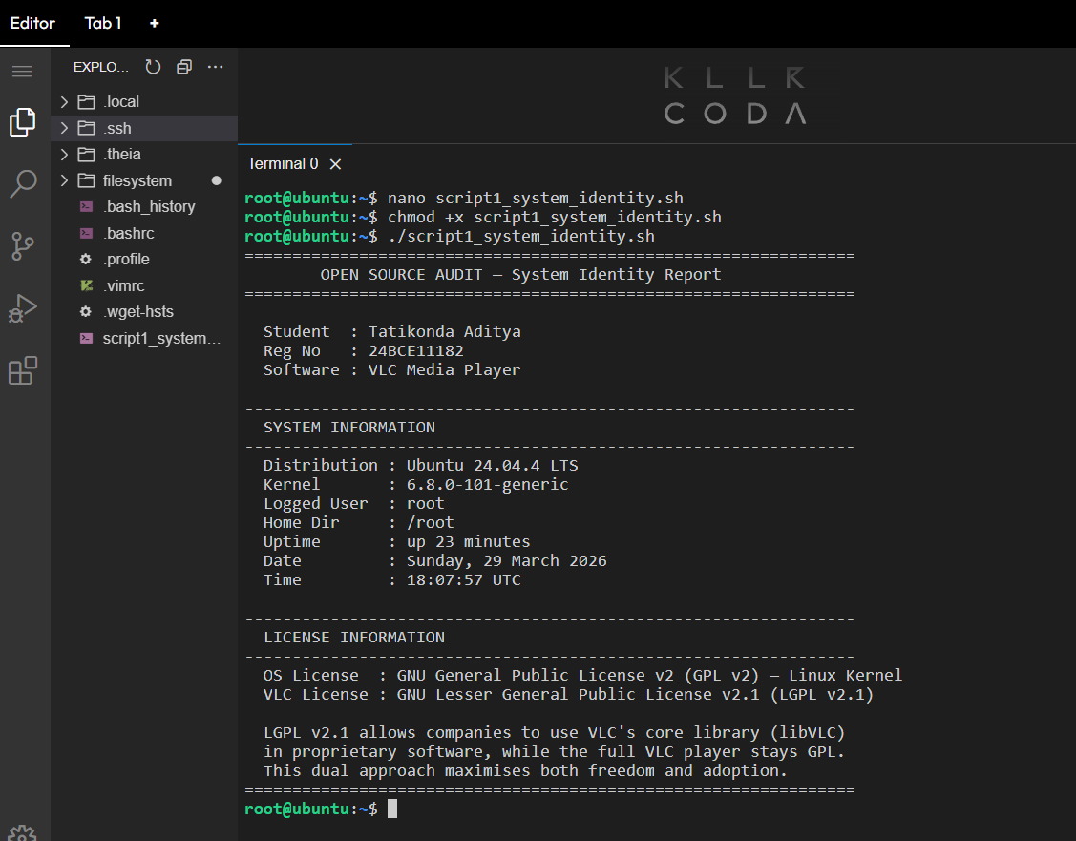

Script 2 — FOSS Package Inspector
File: script2_package_inspector.sh

Checks whether the VLC package is installed on the system. Supports both Debian-based (Ubuntu) and RPM-based (Fedora) distributions. Displays version, license, and summary. Uses a case statement to print philosophy notes about VLC and other open-source packages.

Shell Concepts: if-then-else, case statement, dpkg -l, rpm -qi, grep -E, command -v, pipe chaining, &>/dev/null

Script Code
#!/bin/bash
# ============================================================
# Script 2: FOSS Package Inspector
# Author: Tatikonda Aditya | Reg No: 24BCE11182
# Course: Open Source Software | OSS NGMC Capstone Project
# Description: Checks if VLC is installed, shows its details,
# and prints philosophy notes using a case statement.
# ============================================================

# --- Package we're inspecting ---
PACKAGE="vlc"

echo "================================================================"
echo " FOSS Package Inspector "
echo "================================================================"
echo ""
echo " Checking package: $PACKAGE"
echo ""

# ============================================================
# if-then-else: Check if VLC is installed
# Supports both RPM-based and Debian-based Linux systems
# command -v checks if a tool exists on the system
# ============================================================
if command -v dpkg &>/dev/null && dpkg -l "$PACKAGE" 2>/dev/null | grep -q "^ii"; then
echo " STATUS: $PACKAGE is INSTALLED (Debian-based system)"
echo ""
echo " Package Details:"
echo " ----------------------------------------------------------------"
dpkg -l "$PACKAGE" | grep "^ii" | awk '{printf " Package : %s\n Version : %s\n", $2, $3}'
dpkg-query -W -f=' License : See /usr/share/doc/${Package}/copyright\n Summary : ${Description}\n' "$PACKAGE" 2>/dev/null

elif command -v rpm &>/dev/null && rpm -q "$PACKAGE" &>/dev/null; then
echo " STATUS: $PACKAGE is INSTALLED (RPM-based system)"
echo ""
echo " Package Details:"
echo " ----------------------------------------------------------------"
rpm -qi "$PACKAGE" | grep -E "Version|License|Summary|URL" | \
while IFS=: read -r KEY VAL; do
printf " %-12s: %s\n" "$KEY" "$VAL"
done

elif command -v vlc &>/dev/null; then
VLC_VERSION=$(vlc --version 2>/dev/null | head -1)
echo " STATUS: $PACKAGE is INSTALLED (found in PATH)"
echo " Version : $VLC_VERSION"
echo " License : LGPL v2.1 (core) / GPL v2 (player)"

else
echo " STATUS: $PACKAGE is NOT INSTALLED"
echo " To install: sudo apt install vlc"
fi

echo ""
echo "================================================================"
echo " OPEN SOURCE PHILOSOPHY NOTES"
echo "================================================================"
echo ""

# ============================================================
# case statement: prints a philosophy note per package name
# case is like switch in other languages
# ;; means end of each case block
# *) is the default case
# ============================================================
case $PACKAGE in
vlc)
echo " VLC: Born in a French university dorm room - students who"
echo " just wanted to stream campus TV, built what became the most"
echo " downloaded media player on Earth. 4 billion downloads."
echo " No ads. No premium version. Just freedom."
;;
git)
echo " Git: Built in 10 days by Linus Torvalds out of pure rage"
echo " when a proprietary tool revoked its free license."
;;
httpd | apache2)
echo " Apache: The web server that built the open internet."
;;
mysql | mariadb)
echo " MySQL: Open source at the heart of millions of apps."
;;
firefox)
echo " Firefox: A nonprofit fighting for an open web."
;;
python3 | python)
echo " Python: Shaped entirely by community consensus."
;;
*)
echo " $PACKAGE: Every open-source tool carries a story of"
echo " someone deciding to share rather than hoard their work."
;;
esac

echo ""
echo "================================================================"

Screenshot Placeholder
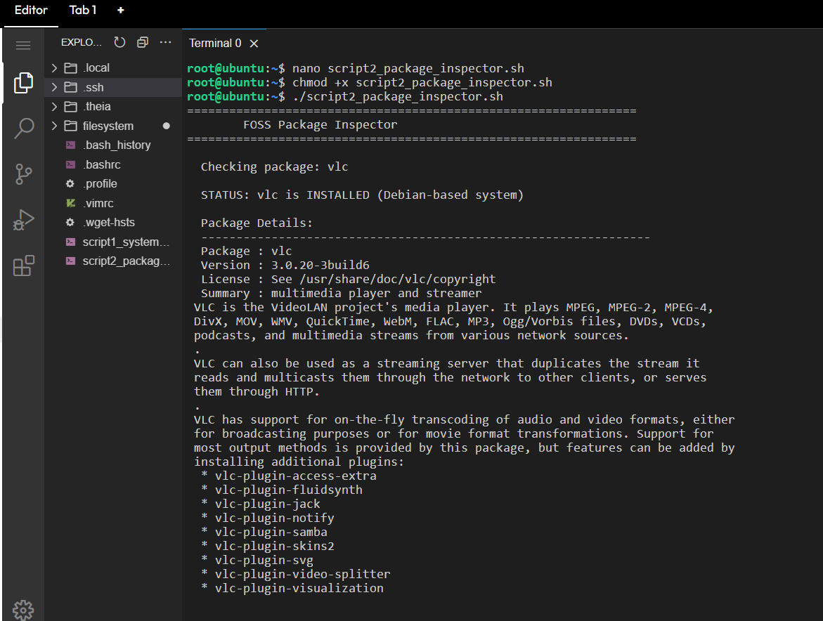


Script 3 — Disk and Permission Auditor
File: script3_disk_permission_auditor.sh
Loops through an array of important system directories and reports permissions, owner, group, and disk usage for each. Also, it specifically audits VLC's user config directory and library directory.
Shell Concepts: Array declaration, for loop over array, [ -d ] directory test, ls -ld, awk, du -sh, cut, printf for formatted output, 2>/dev/null

Script Code
#!/bin/bash
# ============================================================
# Script 3: Disk and Permission Auditor
# Author: Tatikonda Aditya | Reg No: 24BCE11182
# Course: Open Source Software | OSS NGMC Capstone Project
# Description: Loops through system directories, reports
# permissions, owner, group and disk usage.
# Also checks VLC's config directory.
# ============================================================

# --- Array of directories to audit ---
# Arrays in bash: NAME=("item1" "item2" "item3")
DIRS=("/etc" "/var/log" "/home" "/usr/bin" "/tmp" "/var" "/opt")

# --- VLC specific config paths ---
VLC_USER_CONFIG="$HOME/.config/vlc"
VLC_LIB_DIR="/usr/lib/vlc"

echo "================================================================"
echo " Disk and Permission Auditor "
echo "================================================================"
echo ""
echo " Auditing system directories..."
echo ""
printf " %-20s %-12s %-10s %-10s %-10s\n" "Directory" "Permissions" "Owner" "Group" "Size"
echo " ------------------------------------------------------------------------"

# ============================================================
# for loop: goes through each item in the DIRS array
# "${DIRS[@]}" means "all elements of the array"
# ============================================================
for DIR in "${DIRS[@]}"; do
# [ -d "$DIR" ] checks if this directory actually exists
if [ -d "$DIR" ]; then
PERMS=$(ls -ld "$DIR" | awk '{print $1}')
OWNER=$(ls -ld "$DIR" | awk '{print $3}')
GROUP=$(ls -ld "$DIR" | awk '{print $4}')
SIZE=$(du -sh "$DIR" 2>/dev/null | cut -f1)
printf " %-20s %-12s %-10s %-10s %-10s\n" \
"$DIR" "$PERMS" "$OWNER" "$GROUP" "${SIZE:-N/A}"
else
printf " %-20s %-12s\n" "$DIR" "NOT FOUND"
fi
done

echo ""
echo "================================================================"
echo " VLC-SPECIFIC CONFIGURATION AUDIT"
echo " (Chosen software: VLC Media Player)"
echo "================================================================"
echo ""

# Check the VLC user config directory
if [ -d "$VLC_USER_CONFIG" ]; then
PERMS=$(ls -ld "$VLC_USER_CONFIG" | awk '{print $1, $3, $4}')
SIZE=$(du -sh "$VLC_USER_CONFIG" 2>/dev/null | cut -f1)
echo " VLC user config : $VLC_USER_CONFIG"
echo " Permissions : $PERMS"
echo " Size : ${SIZE:-tiny}"
else
echo " VLC user config ($VLC_USER_CONFIG) : NOT FOUND"
echo " (VLC creates this folder on first launch)"
fi

echo ""

# Check VLC library directory
if [ -d "$VLC_LIB_DIR" ]; then
PERMS=$(ls -ld "$VLC_LIB_DIR" | awk '{print $1, $3, $4}')
echo " VLC lib dir : $VLC_LIB_DIR"
echo " Permissions : $PERMS"
else
echo " VLC lib dir ($VLC_LIB_DIR) : NOT FOUND"
echo " (Install VLC first: sudo apt install vlc)"
fi

echo ""
echo "================================================================"
echo " WHY PERMISSIONS MATTER IN OPEN SOURCE"
echo "================================================================"
echo ""
echo " /etc (755) : Config readable by all - transparency"
echo " /home (755) : Each user owns their space - personal freedom"
echo " /tmp (1777) : Sticky bit - shared space but protected"
echo " VLC config : Owned by you - your preferences, your control"
echo "================================================================"

Screenshot Placeholder
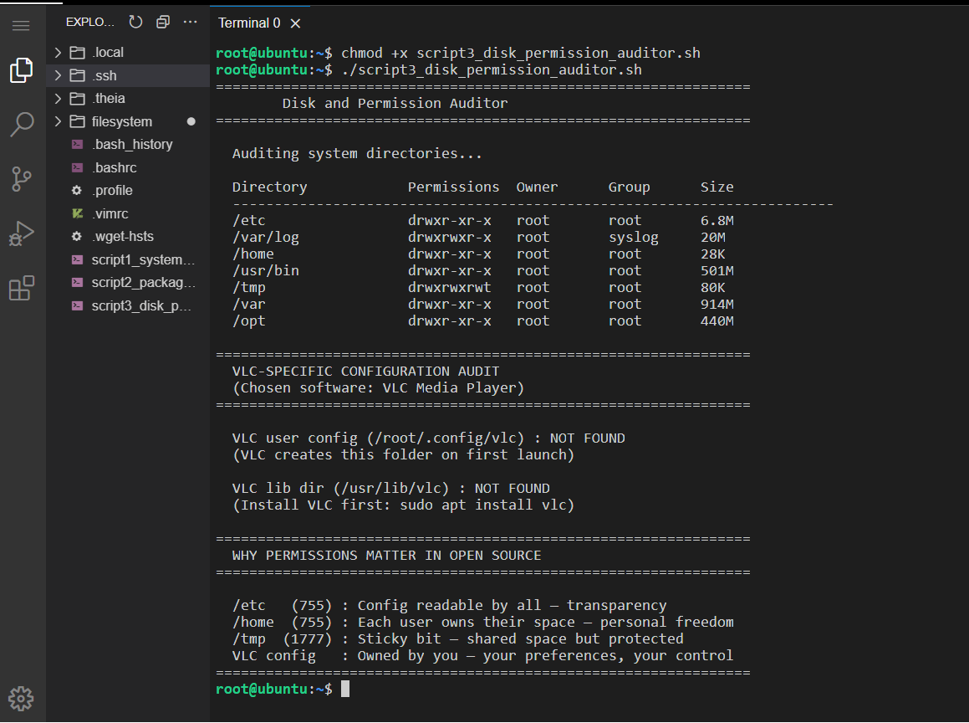

Script 4 — Log File Analyzer
File: script4_log_analyzer.sh
Reads a log file line by line and counts how many lines contain a given keyword (default: error, case-insensitive). Prints the last 5 matching lines. Implements a do-while style retry mechanism to automatically try fallback log file locations if the specified file is not found.
Shell Concepts: Command-line arguments $1 $2, default value assignment ${2:-"error"}, while IFS= read -r loop, if-then inside loop, counter variable $(( )), bash array with +=, array slicing, do-while simulation, exit codes

Script Code
#!/bin/bash
# ============================================================
# Script 4: Log File Analyzer
# Author: Tatikonda Aditya | Reg No: 24BCE11182
# Course: Open Source Software | OSS NGMC Capstone Project
# Description: Reads a log file line by line, counts keyword
# matches, prints last 5 matches.
# Usage: ./script4_log_analyzer.sh /path/to/logfile [KEYWORD]
# ============================================================
# --- Command line arguments ---
LOGFILE=$1
KEYWORD=${2:-"error"}
COUNT=0
MATCH_LINES=()
echo "================================================================"
echo " Log File Analyzer "
echo "================================================================"
echo ""
# ============================================================
# Validate: did the user give us a file path?
# -z means "is this variable empty?"
# ============================================================
if [ -z "$LOGFILE" ]; then
echo " ERROR: No log file specified."
echo " Usage: $0 /path/to/logfile [keyword]"
exit 1
fi
# ============================================================
# Validate: does the file exist?
# If not, try fallback locations (do-while simulation)
# ============================================================
if [ ! -f "$LOGFILE" ]; then
echo " File '$LOGFILE' not found. Trying fallback locations..."
RETRY=true
ATTEMPT=0
while $RETRY; do
ATTEMPT=$((ATTEMPT + 1))
case $ATTEMPT in
1) FALLBACK="/var/log/syslog" ;;
2) FALLBACK="/var/log/messages" ;;
3) FALLBACK="/var/log/kern.log" ;;
esac
if [ -f "$FALLBACK" ]; then
echo " Found fallback: $FALLBACK"
LOGFILE="$FALLBACK"
RETRY=false
elif [ $ATTEMPT -ge 3 ]; then
echo " No log files found."
exit 1
fi
done
fi
echo " Log File : $LOGFILE"
echo " Keyword : '$KEYWORD' (case-insensitive)"
echo ""
echo " Scanning..."
echo ""
# ============================================================
# while read loop: reads file ONE LINE AT A TIME
# IFS= preserves spaces, -r stops backslash interpretation
# ============================================================
while IFS= read -r LINE; do
if echo "$LINE" | grep -iq "$KEYWORD"; then
COUNT=$((COUNT + 1))
MATCH_LINES+=("$LINE")
fi
done < "$LOGFILE"

echo " ----------------------------------------------------------------"
echo " RESULTS"
echo " ----------------------------------------------------------------"
echo " Keyword '$KEYWORD' found: $COUNT time(s)"
echo ""

if [ $COUNT -gt 0 ]; then
echo " Last 5 matching lines:"
echo " ----------------------------------------------------------------"
TOTAL=${#MATCH_LINES[@]}
START=$(( TOTAL > 5 ? TOTAL - 5 : 0 ))
for (( i=START; i<TOTAL; i++ )); do
DISPLAY="${MATCH_LINES[$i]:0:100}"
echo " [$(( i - START + 1 ))] $DISPLAY"
done
else
echo " No matches found for '$KEYWORD'."
fi
echo ""
echo "================================================================"

Screenshot Placeholder 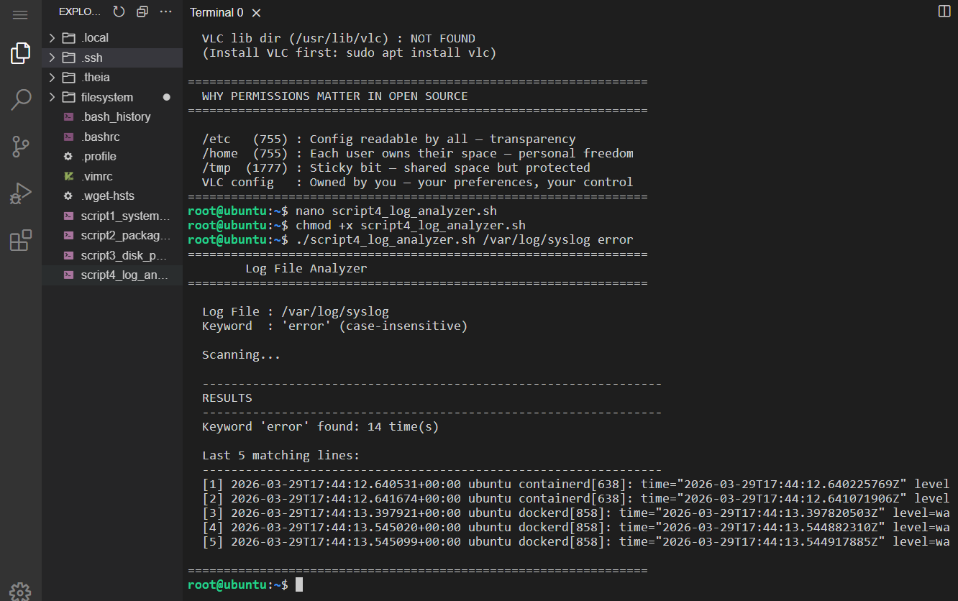

Script 5 — Open Source Manifesto Generator
File: script5_manifesto_generator.sh

Interactively asks the user three questions and composes a personalised open-source philosophy statement. Saves the manifesto to a .txt file named after the current user and displays it on screen.

Shell Concepts: read -p for interactive input, string interpolation in echo, file writing with > and >>, date command, whoami, input validation with [ -z ], function definition as alias pattern, cat for output display

Script Code
#!/bin/bash
# ============================================================
# Script 5: Open Source Manifesto Generator
# Author: Tatikonda Aditya | Reg No: 24BCE11182
# Course: Open Source Software | OSS NGMC Capstone Project
# Description: Asks 3 questions, writes a personalised open
# source philosophy statement to a .txt file.
# ============================================================

# ============================================================
# ALIAS CONCEPT - shown via helper functions
# In a real terminal: alias cls='clear' creates a shortcut
# Here we define functions that work the same way
# ============================================================
print_divider() {
echo "================================================================"
}

print_section() {
echo ""
echo " --- $1 ---"
echo ""
}

clear
print_divider
echo " Open Source Manifesto Generator "
print_divider
echo ""
echo " Answer 3 questions to generate your open source manifesto."
echo ""
print_divider
echo ""

# ============================================================
# read -p : asks the user a question and stores their answer
# ============================================================
read -p " 1. Name one open-source tool you use every day: " TOOL
echo ""
read -p " 2. In one word, what does 'freedom' mean to you? " FREEDOM
echo ""
read -p " 3. Name one thing you would build and share freely: " BUILD
echo ""

# ============================================================
# Input validation: make sure user didn't leave anything blank
# -z checks if a variable is empty (zero length)
# ============================================================
if [ -z "$TOOL" ] || [ -z "$FREEDOM" ] || [ -z "$BUILD" ]; then
echo " ERROR: Please answer all three questions."
exit 1
fi

DATE=$(date '+%d %B %Y')
TIME=$(date '+%H:%M')
USERNAME=$(whoami)
OUTPUT="manifesto_${USERNAME}.txt"

# ============================================================
# Write manifesto to file
# > creates/overwrites the file
# >> appends (adds to end without deleting what's there)
# ============================================================
echo "OPEN SOURCE MANIFESTO" > "$OUTPUT"
echo "Generated on $DATE at $TIME by $USERNAME" >> "$OUTPUT"
echo "================================================================" >> "$OUTPUT"
echo "" >> "$OUTPUT"
echo "I am a student of open source - not just of its code, but of" >> "$OUTPUT"
echo "its values. Every day I use $TOOL, built by people I have never" >> "$OUTPUT"
echo "met, who chose to share their work freely with the world." >> "$OUTPUT"
echo "" >> "$OUTPUT"
echo "To me, freedom means $FREEDOM. Open source is exactly that -" >> "$OUTPUT"
echo "not just software you can download for free, but software you" >> "$OUTPUT"
echo "can read, question, improve, and pass on. VLC taught me this." >> "$OUTPUT"
echo "Students in Paris built a media player for their campus network" >> "$OUTPUT"
echo "and gave it to the world. Four billion downloads later, it still" >> "$OUTPUT"
echo "has no ads, no premium plan, no corporate owner pulling the strings." >> "$OUTPUT"
echo "" >> "$OUTPUT"
echo "One day I want to build $BUILD and release it freely." >> "$OUTPUT"
echo "Not because I have to, but because I understand what it means" >> "$OUTPUT"
echo "to inherit a world built by people who shared." >> "$OUTPUT"
echo "" >> "$OUTPUT"
echo " - $USERNAME, $DATE" >> "$OUTPUT"
echo "================================================================" >> "$OUTPUT"

print_divider
echo " Manifesto saved to: $OUTPUT"
print_divider
echo ""
cat "$OUTPUT"
echo ""
print_divider

Screenshot Placeholder

